Experiment 17
Implement Mobile Price Prediction using appropriate machine learning algorithm
Aim
To implement a Mobile Price Prediction model using an appropriate Machine Learning algorithm (Linear Regression) in Python.
Program
# Mobile Price Prediction using Linear Regression

import pandas as pd
from sklearn.linear_model import LinearRegression
from sklearn.metrics import mean_squared_error

# Dataset
data = {
'RAM': [2, 3, 4, 6, 8],
'Storage': [16, 32, 64, 128, 256],
'Battery': [3000, 3500, 4000, 4500, 5000],
'Price': [8000, 12000, 15000, 22000, 30000]
}

df = pd.DataFrame(data)

# Features and target
X = df[['RAM','Storage','Battery']]
y = df['Price']

# Model
model = LinearRegression()
model.fit(X, y)

# Prediction
y_pred = model.predict(X)

print("Actual Prices:", list(y))
print("Predicted Prices:", list(y_pred))

# Error
mse = mean_squared_error(y, y_pred)
print("Mean Squared Error:", mse)
Output
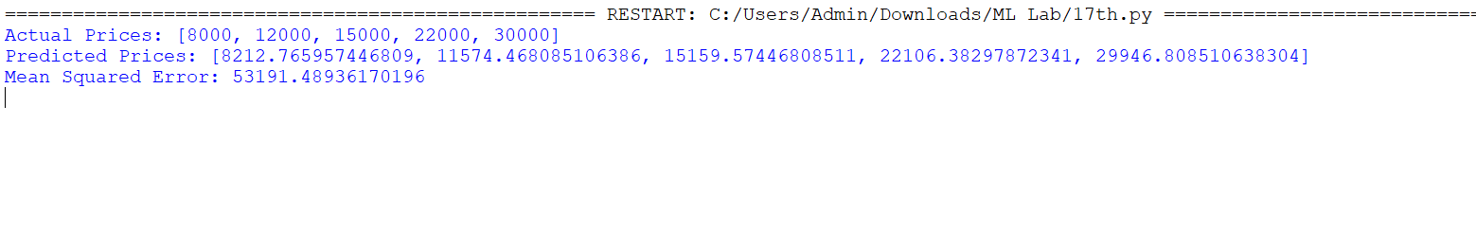

Result
The Mobile Price Prediction model was successfully implemented in Python using Linear Regression, and prices were predicted based on mobile features.

